17. Sexual Reproduction and Development in Animals III *(RHM: Chapter 50)*

______________________________________________________________________________

X. From Germ Layers to Organ Systems *(1173-1180)*

A. Triploblastic Organization

B. Ectoderm Derivatives

1. Nervous system

2. Sensory organs

3. Other derivatives

C. Mesoderm Derivatives

1. Notochord

2. Somites

3. Other derivatives

D. Endoderm Derivatives

1. Digestive tube

2. Pharynx and respiratory system

E. Summary of Body Architecture

XI. Cellular Basis of Development *(1181-1188)*

A. Introduction

B. Determination

1. Genetic control

2. Timing of determination

C. Differentiation

1. Discontinuity of cell populations

2. Stability of differentiated states

3. Association of similar cells

D. Determination in the Egg and Early Embryo

1. Cytoplasmic determinants

2. Polarity in the egg

3. Variations in timing of determination

E. Induction

1. Definition

2. Hierarchies of induction

3. Genetic basis

4. Reciprocal action of induction systems

17-1

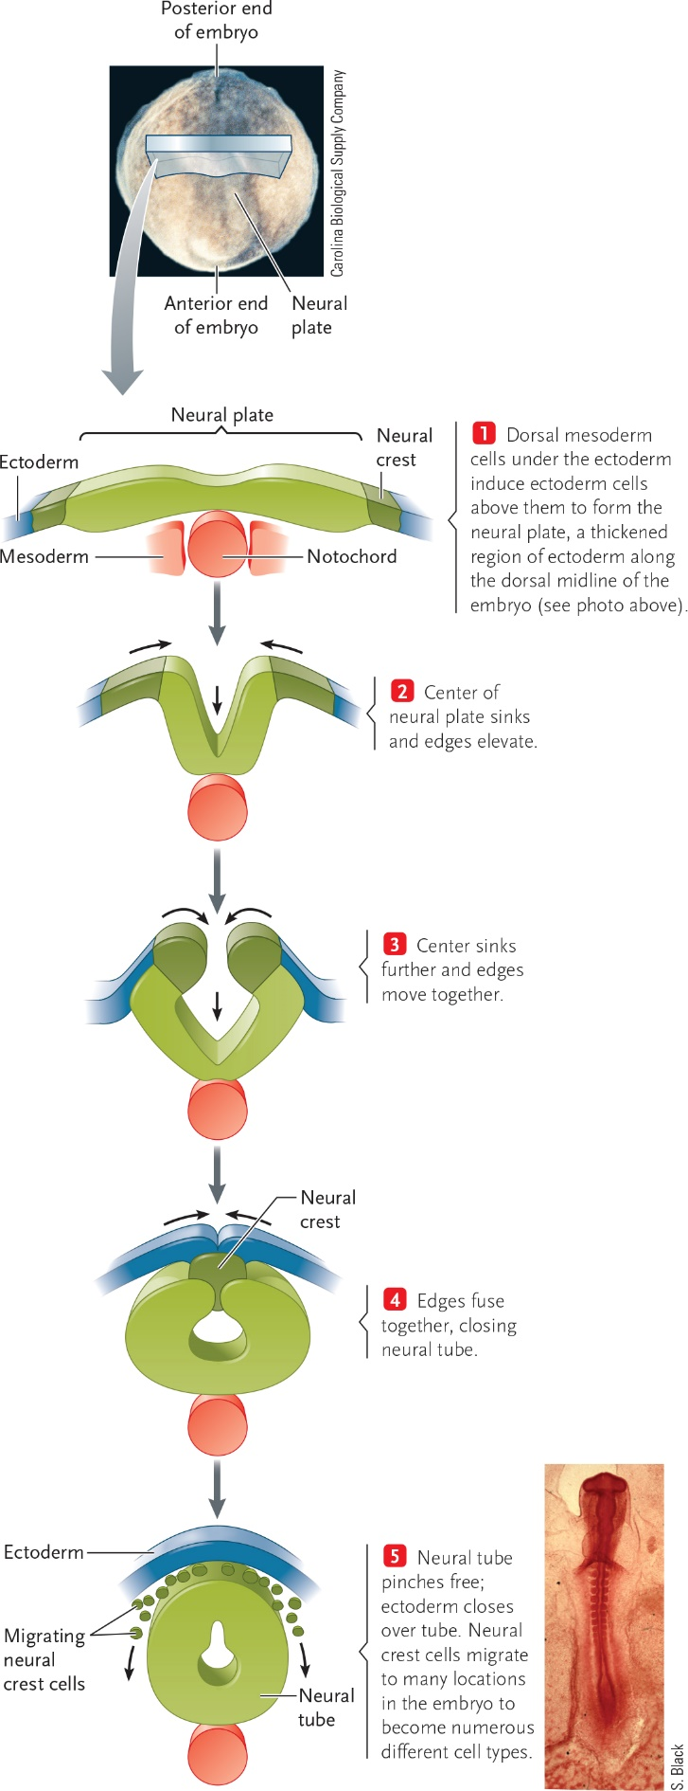

17-2

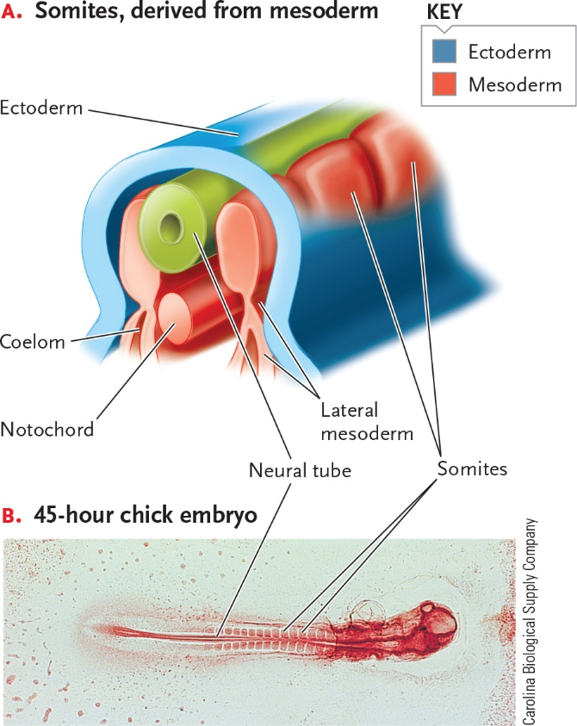

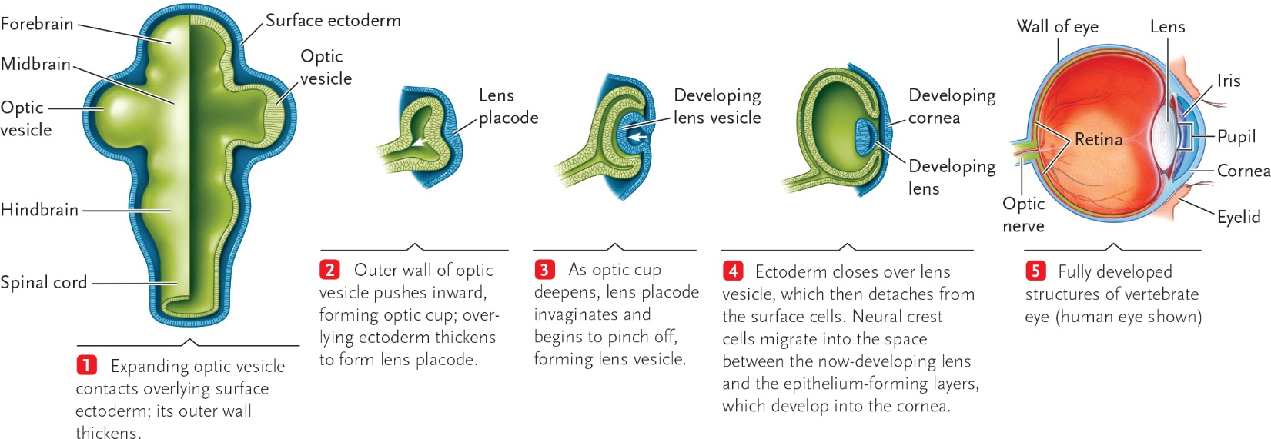17-3

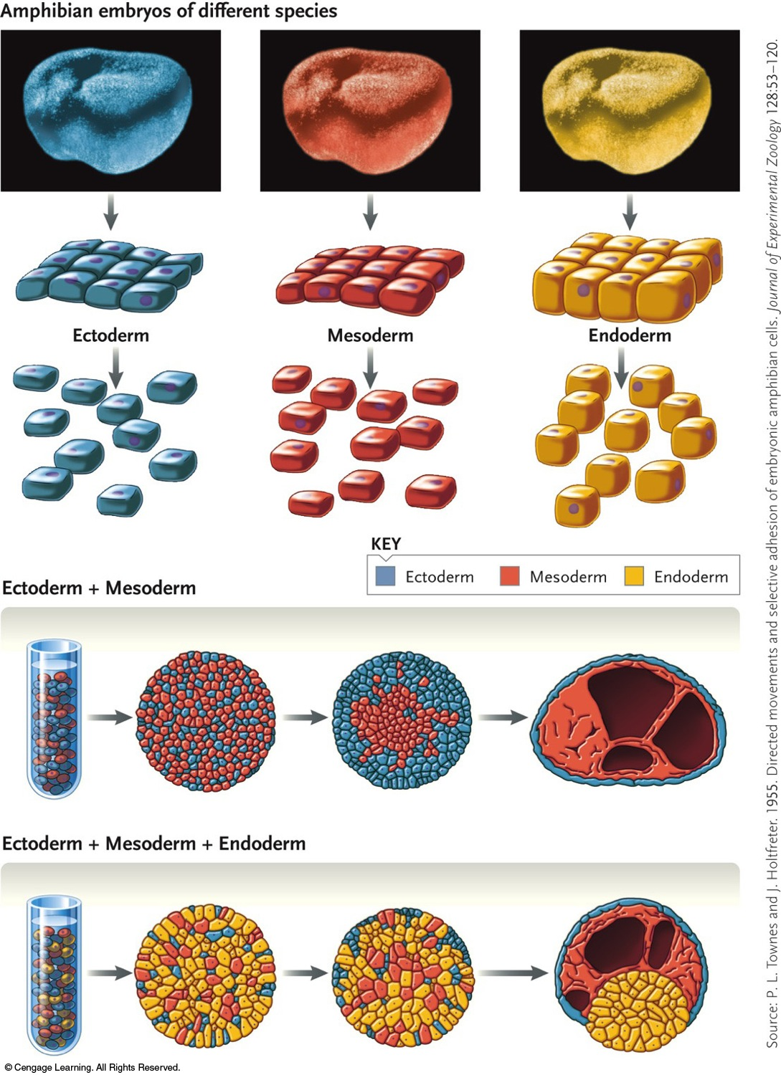

17-4

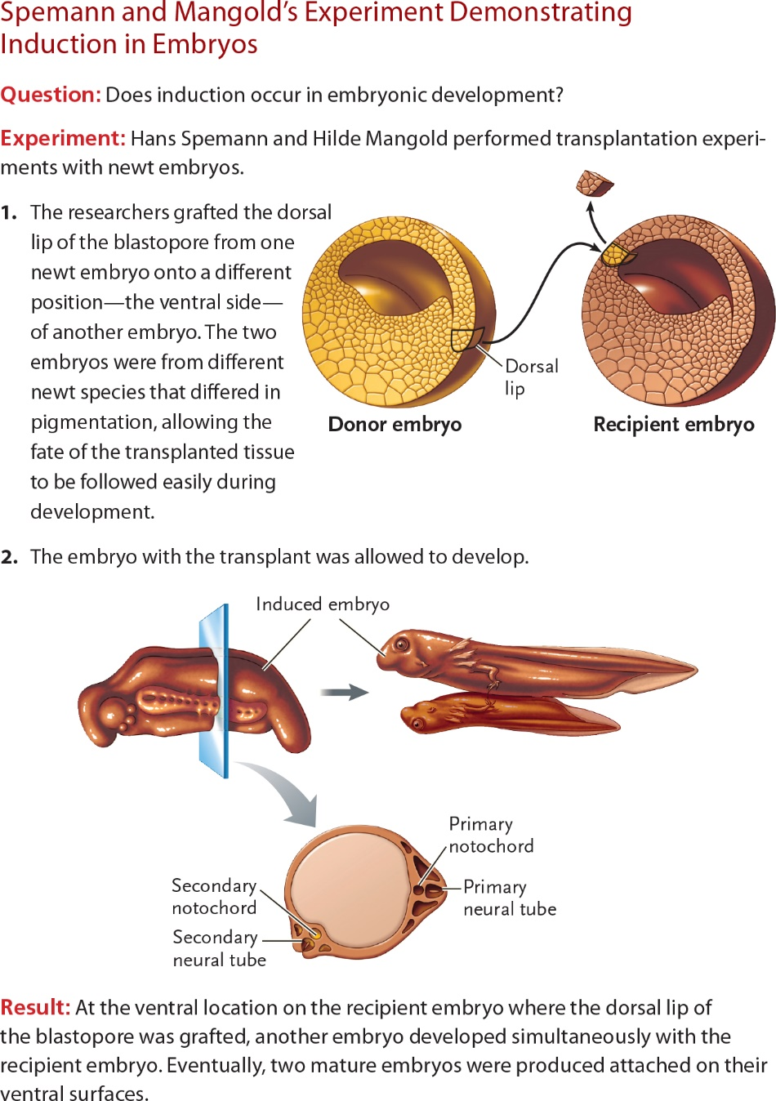

17-5

